EE 8205 – EMBEDDED COMPUTER SYSTEMS
TUTORIAL LAB REPORT
uVision for ARM Cortex M3/M4 CPUs
PREPARED BY: MUHAMMAD IMADULLAH FAROOQUI
SUBMITTED TO: DR. GUL N. KHAN

TASK1 – EXPLORING THE DEBUG SESSION WINDOWS RUNNING Blinky.c
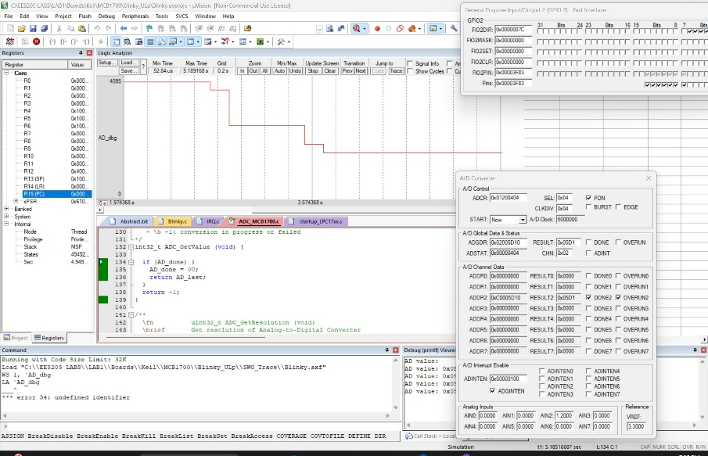
Observing ADC values on logic analyzer after changing from A/D Converter Window
Changing the ADC VALUE from 0V to 3.3V to 1.2V
TASK 2 – PRINTING ADC VALUE AND OBSERVING TOGGLING LEDs
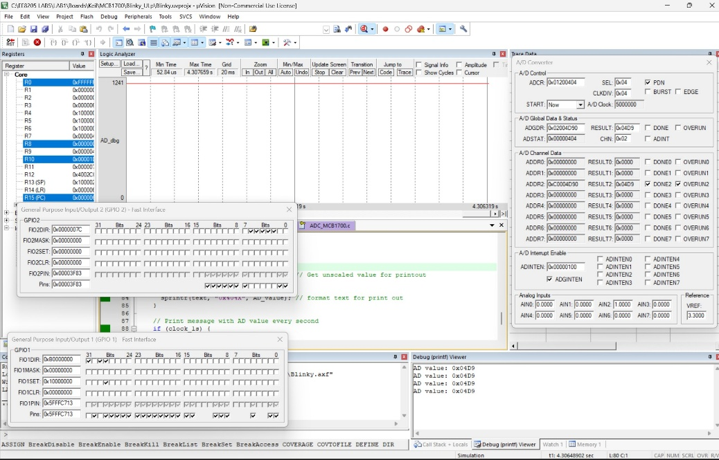
Printing current ADC values while changing from A/D Converter window
GPIOs connected to LEDs toggling from the IRQ handler
TASK 3 (BONUS) – READING & PRINTING JOYSTICK POSITION (Blinky.c modified)
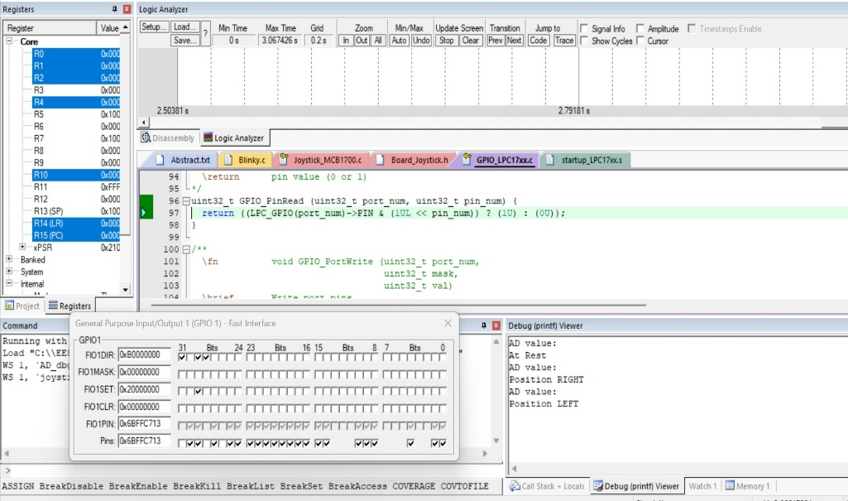
Printing Joystick Position ‘RIGHT’ & ‘LEFT’ while toggling input from Task Interface ‘Pins’
Toggling Joystick Input pins 20,23,24,25 & 26
TASK 3 (BONUS) - MODIFIED CODE HIGHLIGHTED IN GREEN - Blinky.c
#include <stdio.h>  #include "Blinky.h"  #include "LPC17xx.h" // Device header  #include "Board_LED.h" // ::Board Support:LED  #include "Board_ADC.h" // ::Board Support:A/D Converter  #include "Board_Joystick.h"  static char text[10];  static char text_js[20];  // variable to trace in LogicAnalyzer  static volatile uint16_t AD_dbg;  static volatile uint16_t joystick_dbg;  uint16_t ADC_last; // Last converted value  int main (void) {  int32_t res;  int32_t joystick_res;  uint32_t AD_sum = 0U;  uint32_t AD_cnt = 0U;  uint32_t AD_value = 0U;  uint32_t AD_print = 0U;  LED_Initialize(); // LED Initialization  ADC_Initialize(); // ADC Initialization  Joystick_Initialize(); //Inititalize the Joystick  SystemCoreClockUpdate();  SysTick_Config(SystemCoreClock/100U); // Generate interrupt each 10 ms  if (AD_value != AD_print) {  sprintf(text, "0x%04X", AD_value); // format text } | while (1) { //Loop forever  res = ADC_GetValue(); // AD converter input  joystick_res = Joystick_GetState(); //READ JSTIC VAL  if (res != -1) { // If conversion has finished  ADC_last = (uint16_t)res;  AD_sum += ADC_last; // Add AD value to sum  if (++AD_cnt == 16U) { //average over 16 values  AD_cnt = 0U;  AD_value = AD_sum >> 4; // average /by 16  AD_sum = 0U; }}  printf("AD value: %s\r\n", text);  if(joystick_res == 0)  {printf("At Rest\r\n");}  if(joystick_res == 1)  { printf( "Position SELECT\r\n" );}  if(joystick_res == 2)  {printf("Position UP\r\n");} if(joystick_res == 4  {printf("Position DOWN\r\n");}  if(joystick_res == 8)  {printf("Position LEFT\r\n");}  if(joystick_res == 16){  printf("Position RIGHT\r\n");}  AD_print = AD_value; // Get unscaled value for  AD_dbg = (uint16_t)AD_value;  joystick_dbg = (uint16_t)joystick_res;  if (clock_1s) {  clock_1s = 0;

